Visual Rhetoric Analysis

**Introduction**

The image I have chosen is an example of a Venn diagram that was created to illustrate an article titled “*Pokemon Go VS Zombie Apocalypse: A Venn Diagram****,*** written by Rob Fee and published on the website [craveonline.com](http://www.craveonline.com/mandatory/1132691-pokemon-go-zombie-venn-diagram). Venn diagrams were originally used to visualize true and false equivalencies in logic statements, but with the spread of internet memes they have been modified to display humorous or sarcastic comparisons of contrasting cultural elements.

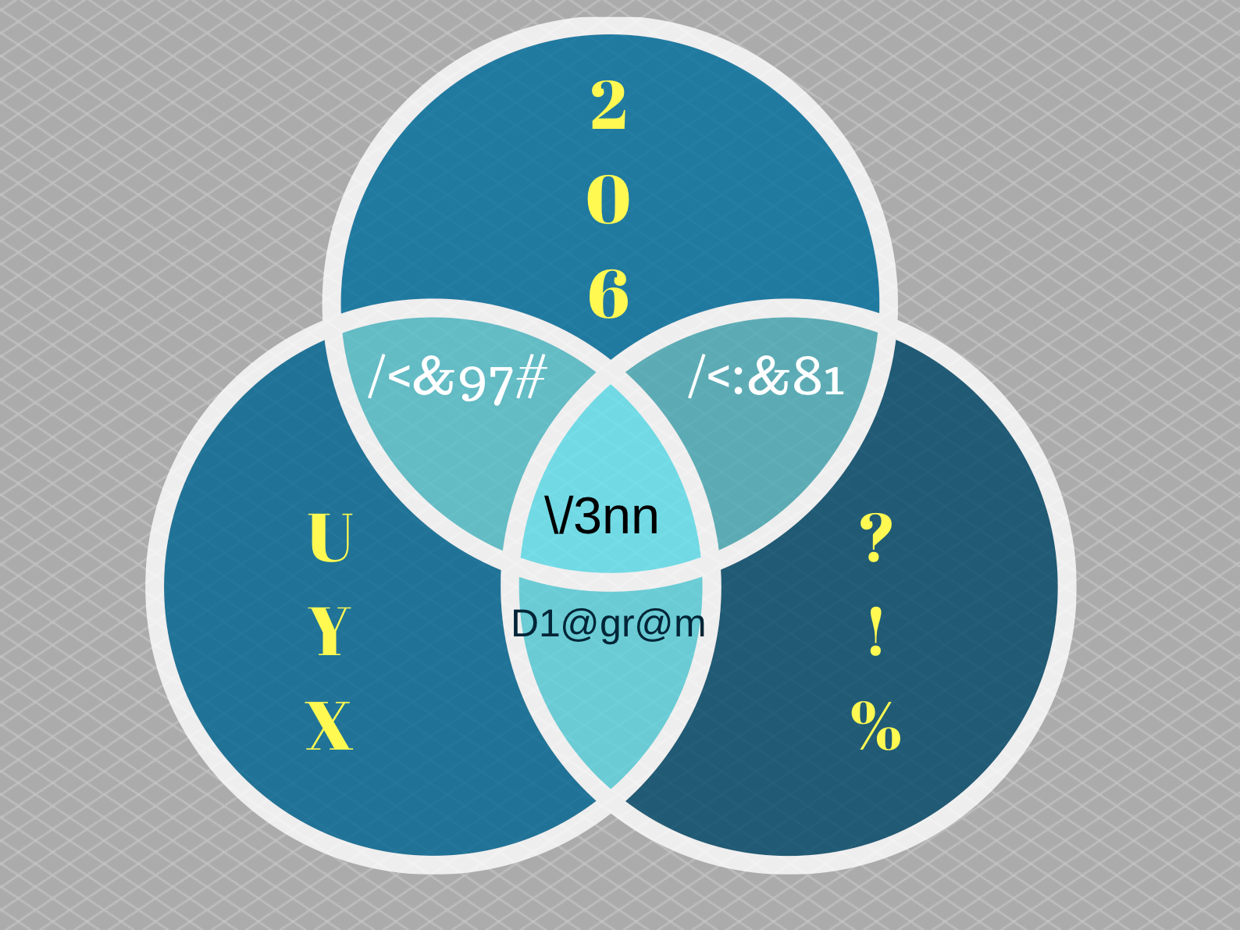

**Venn Diagrams and Memes**

John Venn created this style of diagram as a way to show more detail in logical comparisons than the existing Euler diagrams, and shows logical similarities between two sets, as well as their sub-categories, (2004, Edwards). The Venn method of diagraming logical propositions also was used to illustrate George Boole’s “mathematical logic”, to make the processes more accessible, (2004, Edwards). The rhetoric of a Venn diagram was originally Logos, or logic, the intended rhetoric of the Venn diagram was to have a way to illustrate complex logical prepositions. The internet provides a channel for the sharing and dissemination of texts that were previously considered a piece of technical information and allows a wider audience. As a wider audience becomes familiar with the design and purpose of a Venn diagram there are also contexts where the rhetoric of a Venn diagram shifts. Limor Shifman defines memes as, “units of popular culture that are circulated, imitated, and transformed” (Shifman, 2013), any online text has the potential to be adapted and turned into a meme. In the case of the i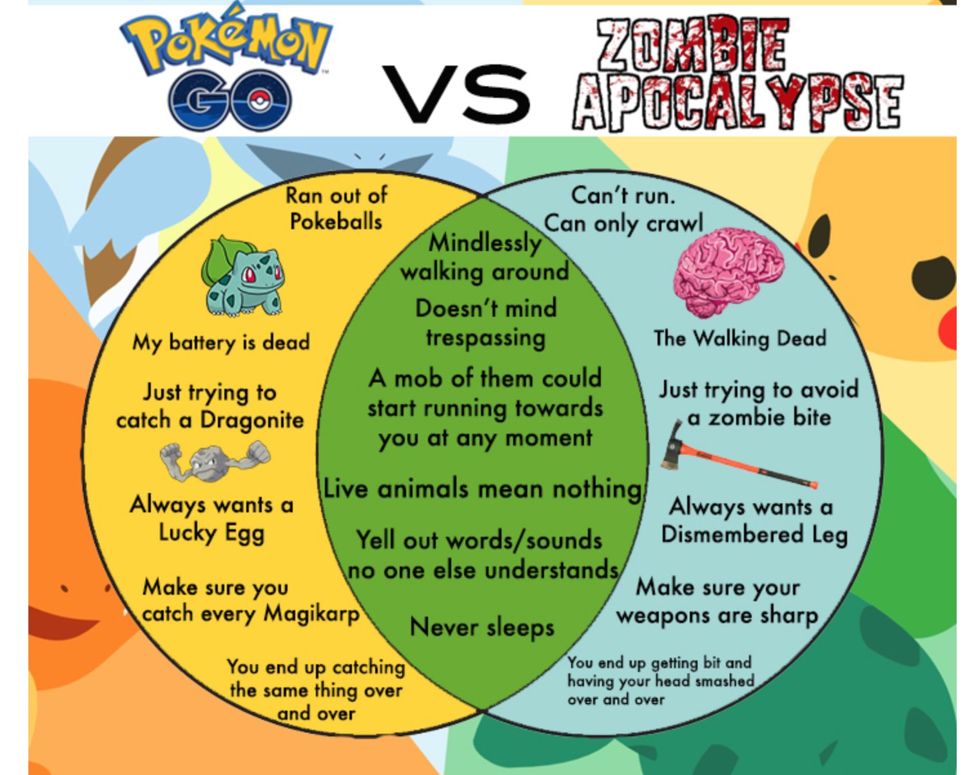mage I selected, *Pokemon Go VS. Zombie Apocalypse: A Venn Diagram*, the audience for this particular Venn diagram changes, and the rhetoric moves from one of logical persuasion to a rhetoric that attempts to persuade through humor.

**Elements of the Image**

There are many elements in an image that work together to establish the rhetoric. I will look at the audience, context, text, using style recommendations found in the [writingcommons.org](https://writingcommons.org/breaking-down-an-image) article, *Breaking Down an Image*.

Audience

The two groups that are being compared in the image are Pokemon Go, an augmented reality game for mobile phone users, and the [zombie apocalypse](https://en.wikipedia.org/wiki/Zombie_apocalypse), a popular trope in zombie themed stories, tv shows, and movies. The audience should be familiar with both of these ideas in order to be persuaded, either convincingly or not, that the image is intended to be humorous.

*Context*

The website that published the image, craveonline.com, publishes short, pop-culture themed articles and photos. The target audience appears to be twenty-something, white, heterosexual, and male who browse the internet for quickly consumed digital content. This meme uses the names and images of Pokemon characters and references to zombies and the tv show, The Walking Dead. These are two pop-culture references that the audience should have opinions on already, the meme doesn’t try to teach the consumer about Pokemon Go or The Walking Dead, but instead it relies on the audience’s knowledge to make the humor obvious.

*Text*

The diagram is comparing three groups of characteristics, one unique to Pokemon Go, one unique to the idea of a zombie apocalypse, at least a zombie apocalypse as portrayed on The Walking Dead, and one group of characteristics supposedly shared by both groups. The center list of shared characteristics implies that Pokemon Go turns its players into zombies, and not that zombies are secretly using the threat of eating brains in order to ["Go Explore. Go Discover. Go Collect."](https://youtu.be/eMobkagZu64). The author uses Pathos when comparing Pokemon Go players to zombies in an attempt to convince the audience that zombies are cooler than Pokemon Go, and while zombie articles don’t just write themselves, there are eight times the number of articles about zombies compared to Pokemon Go. Of course, the concept of zombies, and a zombie apocalypse, have been around a longer than Pokemon, and have been represented in multiple forms of popular media and culture.

**Conclusion**

While a traditional Venn Diagram is used to simplify complex logical relationships between two groups, and / or subgroups, the meme Pokemon Go vs The Walking Dead uses the outline of a Venn Diagram to create relationships between two seemingly unrelated groups. It’s the shift in rhetoric from logos to pathos that makes the Pokemon Go vs The Walking Dead diagram a meme, and the rhetorical elements of audience, context, and text work together to create this shift in tone.

Bibliography

1. A.W.E. Edwards, Cogwheels of the Mind: The Story of Venn diagrams (Baltimore, The Johns Hopkins University Press), 511 [Google books](https://books.google.com/books?hl=en&lr=&id=7_0Thy4V3JIC&oi=fnd&pg=PA1&dq=history+of+venn+diagrams&ots=p1MEhoU37u&sig=i1b9bBFWDqdoQeB6OhYOgt5N1Mg#v=onepage&q=history%20of%20venn%20diagrams&f=false)

2. SHIFMAN, L. Memes in a Digital World: Reconciling with a Conceptual Troublemaker. Journal of Computer-Mediated Communication. 18, 3, 362-377, Apr. 2013. ISSN: 10836101.